ARC 5552 - RMA Dashboard

Quality System > View > RMA Dashboard

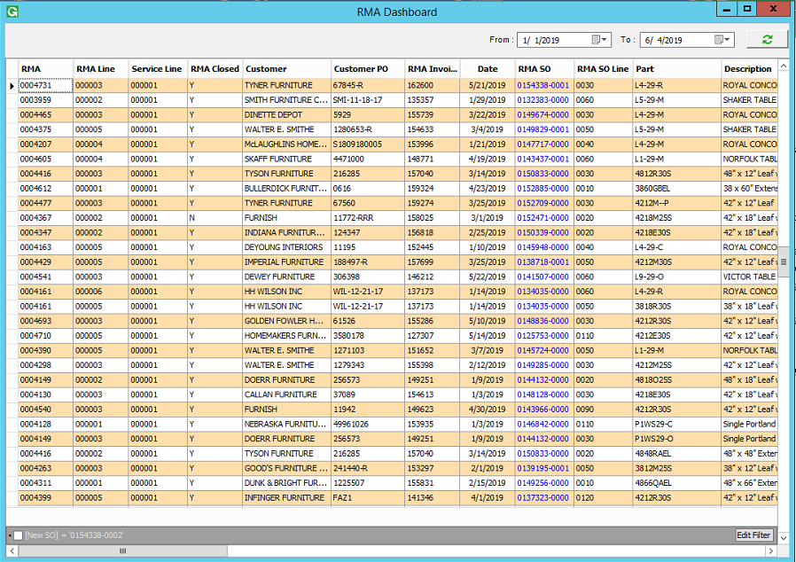

This dashboard is for viewing RMAs and their cost. It can be installed through the ARC, and no additional set up is required.

This is designed to pull in only RMAs where the Sales Order was recreated, types 13, 14, 15, 28, and 30. The work orders are linked to the sales orders via the Customer PO, so this will only pull in correctly when using unique customer POs for all of the RMA related sales orders.

Choose a date range and click the refresh button to load the data in. The data can be grouped, filtered, and sorted in the grid like on most dashboards. Clicking the blue links will open up that Sales Order / Work Order in Global Shop.

Columns can be moved, resized, and hidden like on most dashboards. There are also several extra columns available in the column chooser.

If you right click on the grid, you can reset to the default columns, or export the dashboard to a spreadsheet.